BATCH CODE: PR-202307D

## Our Group Members:

## Muhammad Abdullah Siddiqui :

## (Student1489050)

## Syed Muhammad Taha:

**Submitted To:**

[eprojects@aptech.ac.in](mailto:eprojects@aptech.ac.in)

**Project Instructor:**

**Sir Muhammad Hashir Siddiqui**

## (Student1486391)

## Muhammad Hussain Khan:

## (Student1488941)

## Curriculum Code:

## Muhammad Abdullah Siddiqui :

## (OV-7062-ADSE)

## Syed Muhammad Taha:

## (OV-7066-HDSE)

## Muhammad Hussain Khan:

## (OV-7062-HDSE)

## 

## *TABLE OF CONTENT*

**Project certification…………………………………………………….5**

**Introduction of Sky Gazing………………………………6**

**Requirement specification……………………………………………...7**

**Hardware/software requirements…………………………….……8**

**Home Section…………………………………………………………………...9**

**About us……………………………………………………………………..…159**

**Gallery……………………………………………………….162**

**Contact us ………………………………….……………….164**



**ACKNOLEDGMENT**

**We are thankful to Almighty, ALLAH that by His grace we have been successful. We also thanks to “Sir Muhammad Hashir Siddiqui”**

**we presenting on Dream Weaver in your hands.**

**This is our First Year Semester E-project. We have tried our best & struggled for a better outlook to come. This project has been developed in Dream Weaver. We choose to make Webpage for Cosy Air-conditioner as a project. We find easy to do coding in Dream Weaver.**

**We earnestly hope that this project will provide all the necessarily information required for the user to fulfill their inspiration. However suggestions for improvement of the project will be thankful received & acknowledge**

# **PROJECT CERTIFICATION**

***This is to certify that,***

***Muhammad Abdullah Siddiqui (Enrolment #Student1489050), Syed Muhammad Taha (Enrolment #1486391), Muhammad Hussain Khan(Enrolment #1488941), has successfully designed and developed:***

**Sky Gazing**

***Submitted by***

***Aptech computer Education***

***Date of issue:***

**15-Dec-2023**

***Date of submission:***

**5-Jan-2024.**

# **INTRODUCTION OF SKY GAZING**

**"At Sky Gazing, we stand as pioneers in our field, tirelessly exploring the uncharted territories of technology, astronomy, sustainable travel, and multimedia with curiosity as vast as the cosmos. Our commitment to pushing boundaries, unveiling hidden wonders, and illuminating the extraordinary remains unparalleled."**

**1) The Home Page should be created making use of Frames.**

**2) A Menu should be created which would categorize all the information about the features provided in the Site For e.g. a Menu for Various thing in Space, a Menu for Moons , Nebula etc etc something like that.**

**3) The Webpage display should be categorized according to the things in our galaxy like if a User wants to see only Moons Section then click on view all explore button and select the section that redirect to your selected section .**

**4) A Products of features of Individual things in galaxy should be displayed on the Web Page along with the astronomical Observatories but detailed Features should be stored in Individual Word documents which can be downloaded or viewed by the User who wishes to see the same.**

**5) There Should be a “About Us” page which will give you the information of sky gazing company and also give information of Team members.**

**6) There Should be a “Gallery” page which will contain pictures that applied on a webpage.**

**7) There should be a “Contact Us” page which will have the Address of the Company which is as follows and the mail address which when clicked will invoke the local ail client from where they can send an email**.

# **HARDWARE&SOFTWARE/REQUIRMENT**

**Hardware:**

* Intel Core i3/i5 Processor or higher
* 8 GB RAM or above
* Color SVGA
* 500 GB Hard Disk space
* Mouse
* Keyboard

**Software:**

Technologies to be used:

* Frontend: HTML5, CSS, Bootstrap, JavaScript, jQuery, AngularJS, XML
* Data Store: JSON files or TXT files

Other Requirements:

* Operating Portal: Windows
* Browsers: Edge, Chrome, Mozilla Firefox, Safari

# **HOME SECTION**

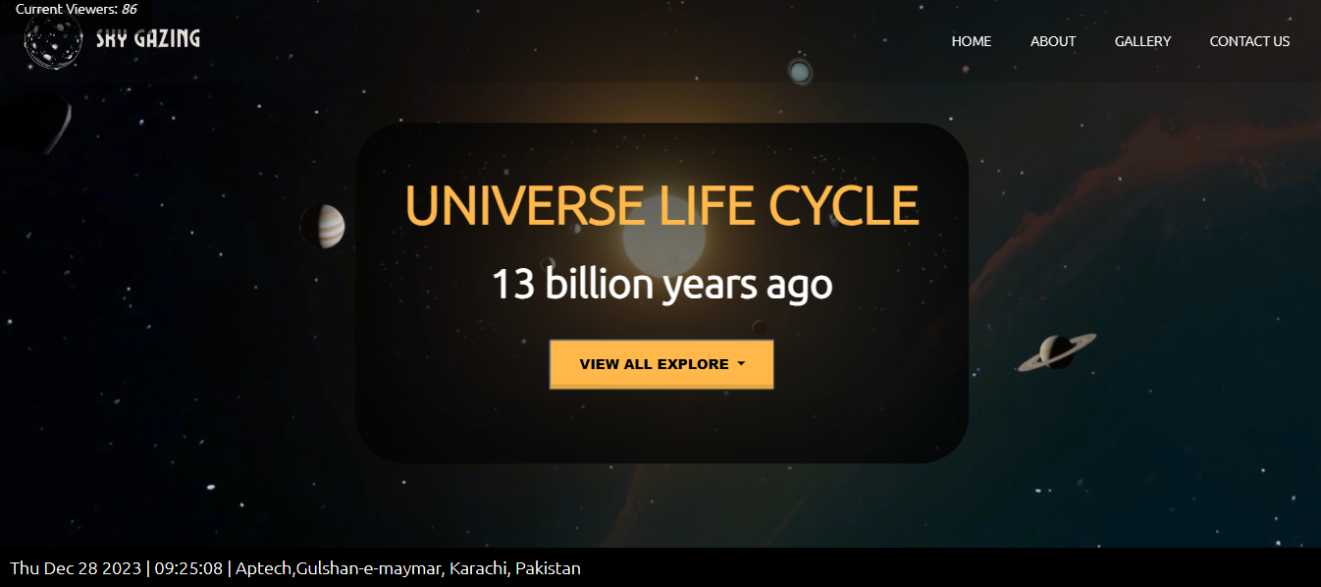

  <div class="background-b">

      <div class="main">

        <header class="header-area">

          <!-- site-navbar start -->

          <div class="navbar-area">

            <div class="container">

              <nav class="site-navbar">

                <!-- site logo -->

                <img class="logo" src="./images/Black_and_White_Hand_Drawn_Moon_logo_-removebg-preview.png" alt="">

                <!-- site menu/nav -->

                <ul>

                  <li><a href="#">Home</a></li>

                  <li><a href="#about">about</a></li>

                  <li><a href="#gallery">gallery</a></li>

                  <li><a href="#contact">contact us</a></li>

                </ul>

                <!-- nav-toggler for mobile version only -->

                <button class="nav-toggler">

                  <span></span>

                </button>

              </nav>

            </div>

          </div><!-- navbar-area end -->

        </header>

      </div>

      <div class="main-banner">

        <video src="./videos/pexels-zch-12722063 (2160p).mp4" autoplay loop muted></video>

        <div class="overlay">

          <h1 class="colour" data-aos="fade-up" data-aos-offset="120">UNIVERSE LIFE CYCLE</h1>

          <h1 class="colour2" data-aos="fade-up" data-aos-offset="0">13 billion years ago</h1>

          <div class="flat-but">

            <div class="dropdown">

              <button class="btn1 btn-secondary gray dropdown-toggle" type="button" data-bs-toggle="dropdown"

                aria-expanded="false" data-aos="zoom-in" data-aos-offset="0">

                View all Explore

              </button>

              <ul class="dropdown-menu">

                <li><a class="dropdown-item" href="#planets">Planets</a></li>

                <li><a class="dropdown-item" href="#Stars">Stars</a></li>

                <li><a class="dropdown-item" href="#Moons">Moons</a></li>

                <li><a class="dropdown-item" href="#Asteroids">Asteroids</a></li>

                <li><a class="dropdown-item" href="#blackhole">Black Holes</a></li>

                <li><a class="dropdown-item" href="#Neutronstar">Neutron Stars</a></li>

                <li><a class="dropdown-item" href="#Comets">Comets</a></li>

                <li><a class="dropdown-item" href="#Nebula">Nebula</a></li>

                <li><a class="dropdown-item" href="#Dust">Dust</a></li>

              </ul>

            </div>

          </div>

        </div>

      </div>

    </div>

    <div>

# **ABOUT US SECTION**

<section id="about">

      <div class="row try p-5">

        <div class="col-md-5">

          <div class="about-sub-1">

            <h1 class="display-4" data-aos="fade-up" data-aos-offset="300">About Us</h1>

            <h3 data-aos="fade-up" data-aos-offset="300">About Sky gazing</h3>

            <p data-aos="fade-up" data-aos-offset="300">

              "Passionate about the cosmos, our mission at Sky Gazing is to inspire and guide enthusiasts through the

              wonders of stargazing, offering expertise and resources for exploring the mysteries of the night sky."

            </p>

          </div>

          <div class="about-sub-2">

            <div id="menu-content16" class="row container custom-card" data-aos="fade-up" data-aos-offset="300">

              <div class="col-6 display-6 my-2 pt-4 text-center team">Team Member</div>

              <div class="col-6 display-6 my-2 pt-4 text-end">

                <div class="slider-controls">

                  <button class="slider-prev16"><i class="fas fa-arrow-left"></i></button>

                  <button class="slider-next16" 1><i class="fas fa-arrow-right"></i></button>

                </div>

              </div>

            </div>

            <div data-aos="fade-up" id="menu-slider16" class="menu-slider16 owl-carousel container custom_card_slider">

              <div class="about-card">

                <h1>Muhammad Abdullah Siddiqui</h1>

                <p>

                  "Welcome to Abdullah Siddiqui Sky Gazing Haven! I'm Muhammad Abdullah Siddiqui, a passionate sky gazer

                  fascinated by the wonders above. This website is a celestial sanctuary crafted to share my love for

                  the stars, planets, and the infinite beauty of our cosmos. Join me on a cosmic journey as we explore

                  the mysteries of the universe through stargazing tips, celestial events, astrophotography, and

                  captivating stories about our cosmic neighborhood. Let's navigate the vastness of the night sky

                  together and uncover the enchanting secrets it holds."

                </p>

              </div>

              <div class="about-card">

                <h1>Syed Muhammad Taha</h1>

                <p>

                  "Welcome to Syed Muhammad Taha's Sky Gazing Haven! I'm Syed Muhammad Taha, a passionate sky gazer

                  fascinated by the wonders above. This website is a celestial sanctuary crafted to share my love for

                  the stars, planets, and the infinite beauty of our cosmos. Join me on a cosmic journey as we explore

                  the mysteries of the universe through stargazing tips, celestial events, astrophotography, and

                  captivating stories about our cosmic neighborhood. Let's navigate the vastness of the night sky

                  together and uncover the enchanting secrets it holds."

                </p>

              </div>

              <div class="about-card">

                <h1>Muhammad Hussain Khan</h1>

                <p>

                  "Welcome to Muhammad Hussain Khan Sky Gazing Haven! I'm Muhammad Hussain Khan, a passionate sky gazer

                  fascinated by the wonders above. This website is a celestial sanctuary crafted to share my love for

                  the stars, planets, and the infinite beauty of our cosmos. Join me on a cosmic journey as we explore

                  the mysteries of the universe through stargazing tips, celestial events, astrophotography, and

                  captivating stories about our cosmic neighborhood. Let's navigate the vastness of the night sky

                  together and uncover the enchanting secrets it holds."

                </p>

              </div>

            </div>

            <script>

              $(document).ready(function () {

                $('#menu-slider16').owlCarousel({

                  items: 1,

                  loop: true,

                  margin: 10,

                  nav: false,

                  dots: false,

                });

                //

                //ends

                // Custom navigation

                $('#menu-content16 .slider-prev16').click(function () {

                  $('#menu-slider16').trigger('prev.owl.carousel');

                });

                $('#menu-content16 .slider-next16').click(function () {

                  $('#menu-slider16').trigger('next.owl.carousel');

                });

              });

            </script>

# **Gallery Section**

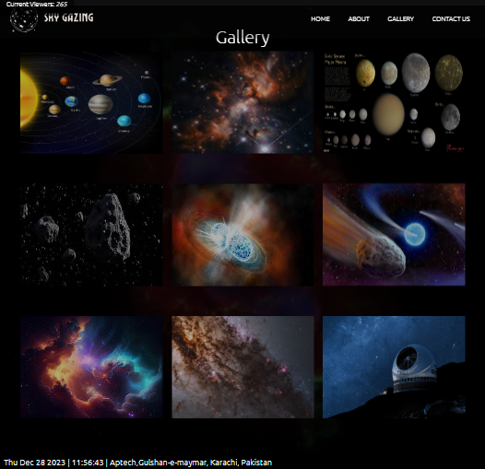

<!-- gallery -->

    <section id="gallery">

      <h1>Gallery</h1>

      <div class="gall-main" data-aos="fade-up" data-aos-offset="300">

        <div class="gall-grid">

          <img src="./images/solar-system.jpg" alt="" data-aos-offset="300">

          <span class="btn btn-secondary" data-bs-toggle="modal" data-bs-target="#myModalaa">Planets</span>

        </div>

        <div class="gall-grid" data-aos="fade-up" data-aos-offset="300">

          <img src="./images/starses.jpeg" alt="">

          <span class="btn btn-secondary" data-bs-toggle="modal" data-bs-target="#myModala">Stars</span>

        </div>

        <div class="gall-grid" data-aos="fade-up" data-aos-offset="300">

          <img src="./images/moons.jpg" alt="">

          <span class="btn btn-secondary" data-bs-toggle="modal" data-bs-target="#myModalb">Moons</span>

        </div>

        <div class="gall-grid" data-aos="fade-up" data-aos-offset="300">

          <img src="./images/asterioses.jpeg" alt="">

          <span class="btn btn-secondary" data-bs-toggle="modal" data-bs-target="#myModalc">Asteroids</span>

        </div>

        <div class="gall-grid" data-aos="fade-up" data-aos-offset="300">

          <img src="./images/neutronstars.jpeg" alt="">

          <span class="btn btn-secondary" data-bs-toggle="modal" data-bs-target="#myModald">Neutron Stars</span>

        </div>

        <div class="gall-grid" data-aos="fade-up" data-aos-offset="300">

          <img src="./images/cometss.jpg" alt="">

          <span class="btn btn-secondary" data-bs-toggle="modal" data-bs-target="#myModale">Comets</span>

        </div>

        <div class="gall-grid" data-aos="fade-up" data-aos-offset="300">

          <img src="./images/nebulas.jpeg" alt="">

          <span class="btn btn-secondary" data-bs-toggle="modal" data-bs-target="#myModalf">Nebula</span>

        </div>

        <div class="gall-grid" data-aos="fade-up" data-aos-offset="300">

          <img src="./images/dustes.jpg" alt="">

          <span class="btn btn-secondary" data-bs-toggle="modal" data-bs-target="#myModalg">Dust</span>

        </div>

        <div class="gall-grid" data-aos="fade-up" data-aos-offset="300">

          <img src="./images/observatoriess.jpg" alt="">

          <span class="btn btn-secondary" data-bs-toggle="modal" data-bs-target="#myModalh">Observatories</span>

        </div>

      </div>

    </section>

# **CONTACT US SECTION**

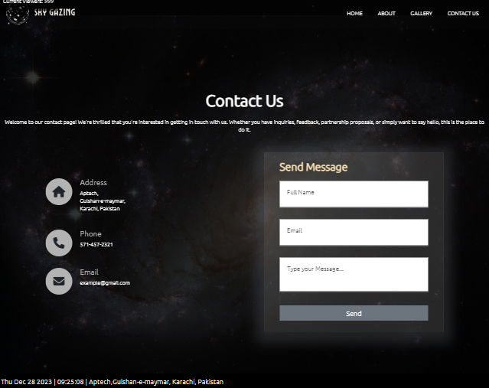

    <main class="cd__main">

      <!-- Start DEMO HTML (Use the following code into your project)-->

      <section id="contact">

        <div class="section-header">

          <div class="container" data-aos="fade-down" data-aos-offset="300">

            <h2>Contact Us</h2>

            <p>Welcome to our contact page! We're thrilled that you're interested in getting in touch with us. Whether

              you have inquiries, feedback, partnership proposals, or simply want to say hello, this is the place to do

              it.</p>

          </div>

        </div>

        <div class="container1">

          <div class="row1">

            <div class="contact-info" data-aos="fade-up">

              <div class="contact-info-item">

                <div class="contact-info-icon">

                  <i class="fas fa-home"></i>

                </div>

                <div class="contact-info-content">

                  <h4>Address</h4>

                  <p>Aptech,<br> Gulshan-e-maymar,<br> Karachi, Pakistan</p>

                </div>

              </div>

              <div class="contact-info-item">

                <div class="contact-info-icon">

                  <i class="fas fa-phone"></i>

                </div>

                <div class="contact-info-content">

                  <h4>Phone</h4>

                  <p>571-457-2321</p>

                </div>

              </div>

              <div class="contact-info-item">

                <div class="contact-info-icon">

                  <i class="fas fa-envelope"></i>

                </div>

                <div class="contact-info-content">

                  <h4>Email</h4>

                  <p>example@gmail.com</p>

                </div>

              </div>

            </div>

            <div class="contact-form" data-aos="zoom-in">

              <form action="" id="contact-form">

                <h2>Send Message</h2>

                <div class="input-box">

                  <input type="text" required="true" name="">

                  <span>Full Name</span>

                </div>

                <div class="input-box">

                  <input type="email" required="true" name="">

                  <span>Email</span>

                </div>

                <div class="input-box">

                  <textarea required="true" name=""></textarea>

                  <span>Type your Message...</span>

                </div>

                <div class="input-box ">

                  <input style="border: none;" class="bg-secondary text-center" type="submit" value="Send" name="">

                </div>

              </form>

            </div>

          </div>

        </div>

      </section>

      <!-- END EDMO HTML (Happy Coding!)-->

    </main>

**THANK YOU**

**……….YOUR REGARDS……….**

**“IF YOU ANY PROBLEMS PLEASE CHECK OUR WEBSITES”**